United Way Campaign Email Templates
Below are email templates you can use to help communicate to employees about your United Way Campaign. Choose to use messaging that matches your businesses’ philanthropic goals and company values.

Download any of the images included below to add your logo or customize to your campaign, here: https://www.uwofsc.org/get-involved/give/campaign-toolkit/

Reach out to Emily Kaiser (emily@uwofsc.org) or Katelyn Piper (katelyn@uwofsc.org) for any assistance.
________________________________________________________________________________________

Email 1 | United Way Campaign Kickoff Announcement (2 weeks prior to your campaign)

Mark your Calendars!
Each year [Company Name] supports United Way of Sheboygan County by raising funds for our neighbors in need.

Mark your calendars for the following events and due dates!
- [DATE] Campaign Kickoff | [NAME OF CEO] invites you to join us at [LOCATION (virtual or in-person)] to kickoff this year’s United Way Campaign! [Add any other fun details or agenda for the kickoff here]
- [DATE] Lunch & Learn | Join us at [LOCATION (virtual or in-person)] to learn more about where your donation goes when you give to United Way!
- [DATE] Campaign Pledge Forms Due | Complete your pledge form (online or via paper) to [CONTACT PERSON] by [DATE] for your chance to win [add any giving thank you incentives here].

Last year, employees raised [Dollar Amount] and [Company Name] matched your contribution, totaling [TOTAL DONATION AMOUNT]. Together with donors from around the county, our contributions supported over 41,000 households in Sheboygan County last year alone.

Our community needs your help now more than ever. We are looking forward to seeing you at our company-wide kickoff and your continued support to keep Sheboygan County Strong! United We Rise.

See you at the kickoff!

PS – for questions, please reach out to [CONTACT].

Signed by your CEO or Department Manager.

________________________________________________________________________________________

Email 2 | United Way Campaign Kickoff Reminder (2 days prior to your kickoff)

We are just a few days away from our United Way Campaign Kickoff!

Last year, thanks to your gift, more than 41,000 individuals and families were supported by local programs and services.

We invest in United Way of Sheboygan County because our dollars stay local. Last year, our combined gifts supported local Partner Agencies in the areas of Health, Education, and Financial Stability.

Join us at the kickoff to learn more about the impact your gifts made last year.

[Add kickoff information, such as date, time, location and agenda]

PS – for questions, please reach out to [CONTACT].

Signed by your CEO or Department Manager.
________________________________________________________________________________________

Email 3 | Our United Way Campaign has started!

[Insert picture from kickoff]
Our United Way Campaign has begun!

Now is your chance to continue to be or start being a part of supporting families and individuals that need a hand up.

Today, a third of the population in Sheboygan County is living paycheck to paycheck or under the poverty level. You can be a part of the solution.

Complete the attached pledge form and turn it into [CONTACT] by [DATE] to make a difference. *Note, payroll deductions start [DATE].

As a thank you, for turning in your completed pledge form – all employees will be entered in a drawing to win [INCENTIVE].

For questions, please reach out to [CONTACT].

Signed by your CEO or Department Manager.

________________________________________________________________________________________

Email 4 | Our Campaign Continues…

Did you know?

Last year, leadership and life skills were taught to 3,100 children in Sheboygan County through programs supported by United Way of Sheboygan County.

Education is one of the pillars to a successful live. United Way of Sheboygan County unites to make a difference in the lives of children, whom are the future of this community.

[Insert picture of employee turning in their form]
[NAME OF EMPLOYEE] gives to support education. Join her/him in making a donation to United Way of Sheboygan County.

Reminder: Make sure you complete your pledge form and turn it into [CONTACT] by [DATE] to make a difference. *Note, payroll deductions start [DATE].

As a thank you, for turning in your completed pledge form – all employees will be entered in a drawing to win [INCENTIVE].

For questions, please reach out to [CONTACT].

Signed by your CEO or Department Manager.

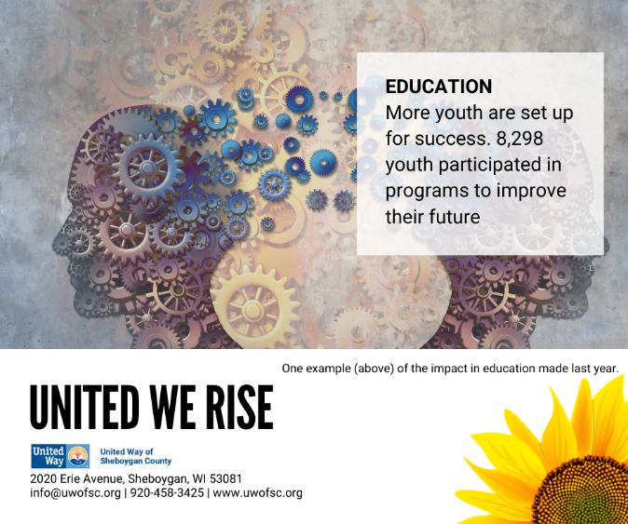
________________________________________________________________________________________

Email 5 | Our Campaign Continues…

Did you know?

Last year, 578 students received weekly school-based mental health therapy in every school district in Sheboygan County through programs supported by United Way of Sheboygan County.

Health is one of the pillars to a successful life. United Way of Sheboygan County unites to make sure everyone from every walk of life has access to health.

[Insert picture of employee turning in their form]
[NAME OF EMPLOYEE] gives to support the health of everyone. Join her/him in making a donation to United Way of Sheboygan County.

Reminder: Make sure you complete your pledge form and turn it into [CONTACT] by [DATE] to make a difference. *Note, payroll deductions start [DATE].

As a thank you, for turning in your completed pledge form – all employees will be entered in a drawing to win [INCENTIVE].

For questions, please reach out to [CONTACT].

Signed by your CEO or Department Manager.
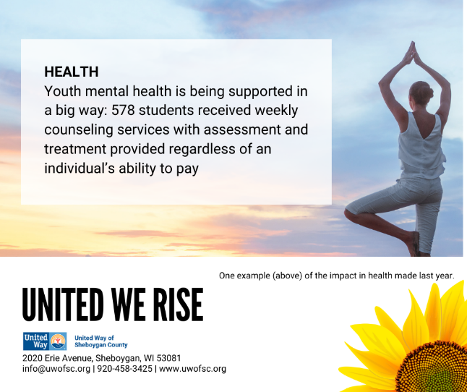
________________________________________________________________________________________

Email 6 | Our Campaign Continues…

Did you know?

Last year, 435 households in Sheboygan County were provided rental assistance so families could overcome barriers and gain secure housing through programs supported by United Way of Sheboygan County.

Financial Stability is one of the pillars to a successful live. United Way of Sheboygan County unites to help all individuals and families go from surviving to thriving.

[Insert picture of employee turning in their form]
[NAME OF EMPLOYEE] gives to support the Financial Stability of those in need. Join her/him in making a donation to United Way of Sheboygan County.

Reminder: Make sure you complete your pledge form and turn it into [CONTACT] by [DATE] to make a difference. *Note, payroll deductions start [DATE].

As a thank you, for turning in your completed pledge form – all employees will be entered in a drawing to win [INCENTIVE].

For questions, please reach out to [CONTACT].

Signed by your CEO or Department Manager.
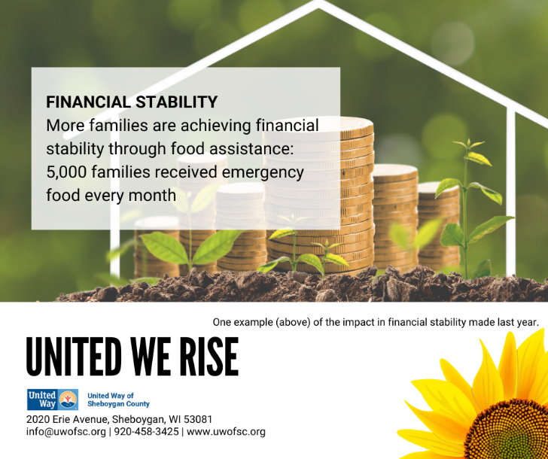
________________________________________________________________________________________

Email 7 | Lunch and Learn Invite

Did you know?

United Way of Sheboygan County supports local programs under the pillars of education, health, and financial stability, three community impact initiatives, and other community programing, such as Food for Tomorrow and 2-1-1 Resource Center.

Join us on [DATE] to hear more about the impact you can make by contributing to United Way.

Sign up for the Lunch and Learn [HERE].

For questions, please reach out to [CONTACT].

Signed by your CEO or Department Manager.

________________________________________________________________________________________

Email 8 | Partner Spotlight Video

Did you know?

One of the Agencies United Way of Sheboygan County supports is [AGENCY].

Each year local programs focusing on education, health and financial stability apply for funding. Volunteers review program applications and make funding decisions, holding each agency accountable for the funds used. This ensures that the contribution you make to United Way is being used efficiently and makes a big impact in the community.

Hear more directly from [AGENCY] about their program(s) and the benefit of partnering with United Way here: [INSERT VIDEO OR LINK].

For questions, please reach out to [CONTACT].

Signed by your CEO or Department Manager.

________________________________________________________________________________________

Email 9 | Emerging Leaders

Did you know?

United Way of Sheboygan County recently launched and Emerging Leaders program and you can be a part of the program too!

Recommended for civic-minded individuals age 40 and under, the United Way of Sheboygan County Emerging Leaders program is a network of committed, passionate, and generous young adults dedicated to creating a lasting impact in our community.

Hear more about the program directly from the Emerging Leaders: [INSERT VIDEO OR LINK].

Benefits:
- Professional and personal growth through leadership and development opportunities and events
- Ability to makes connections with other young leaders in the community while giving back through volunteer opportunities
- Expand your network and enhance your skills by interacting with individuals in diverse fields and learning about United Way partnerships
- Knowing you are making a difference in the lives of others
Membership Criteria:
- Gives a minimum of $10/week or $500 annually to the United Way of Sheboygan County
- Voluntarily opt-in to the program

For questions, please reach out to [CONTACT].

Signed by your CEO or Department Manager.

________________________________________________________________________________________

Email 10 | Board Insights

Did you know?

United Way of Sheboygan County is a local, autonomous organization governed by a volunteer Board of Directors.

Policies, activities, procedures, and programs we support are determined right here at home. The community volunteers who lead United Way come from all walks of life and reflect the cultural diversity of our area.

The Board of Directors has a unique perspective on the work of United Way as they guide the direction of the organization. Hear their insights here: [INSERT VIDEO OR LINK].

For questions, please reach out to [CONTACT].

Signed by your CEO or Department Manager.

________________________________________________________________________________________

Email 11 | Final Campaign Reminder

Today is your last day to participate in [COMPANY]’s United Way Campaign.

Join the XXX employees that have already pledged to make a difference locally. Any amount makes a difference.

- $5 can provide 1 healthy snack and hour-long program to inspire wholesome food choices for students

- $25 can provide 1-hour of mediation for a youth who is homeless or a runaway

- $100 can provide 3 nights of shelter, 3 meals each day, casework and toiletries for a homeless individual

- $250 can provide (2) 1-hour budget and credit counseling sessions, supporting financial stability

Complete your pledge form and turn it into [CONTACT] by the end of today to make a difference for someone in need.

All employees that participate in our 2021-2022 United Way Campaign are entered in a drawing to win [INCENTIVE(s)].

For questions, please reach out to [CONTACT].

Signed by your CEO or Department Manager.

________________________________________________________________________________________

Email 12 | CELEBRATION EMAIL

Today we celebrate the caring power we have together at [company].

Our campaign in numbers….

- XXX employees made a pledge.
- XXX participated in the United Way Campaign Kickoff.
- XXX participated in the United Way Lunch & Learn.
- XX% employees participation in the United Way Campaign.
- $XXX pledged by employees.

We know that these are more than just numbers. These numbers amount to more families and individuals receiving the support they need to thrive.

United, we are helping our neighbors, loved ones, and friends rise from the hardships brought on by these difficult times.

As a thank you, [Company Name] is matching your contribution dollar for dollar. This means the impact your contribution is worth is now doubled.

Giving to United Way means you recognize that when everyone has access to quality education, health, and financial stability – then we all win.

Don’t think we forgot the incentives! Here is/are the winner/s of our giving drawing:
[Include list or images of winner(s)]

Thank you for being a part of the solution. UNITED WE RISE.

Signed by your CEO or Department Manager.

