HOW TO POST AN ADVANCED EVENT (6 Steps)
- Login to your account (Login page: https://volunteersheboygan.galaxydigital.com/user/login/)
- Then click the ‘My Agency’ on the top of your screen.
- Go to your Agency Management Area and click the Advanced Events link.
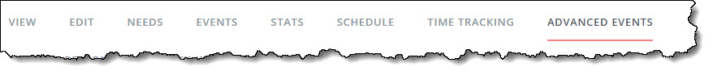
- Click the option that corresponds to your volunteer opportunity type: Volunteer Opportunity or Wish List
- Then it will take you to the ‘Need Information’ page. On this page, answer all applicable and required fields on. This page has several sections, which are listed in the table on the next page.
Note: Your response may prompt a field for further information. For example, if an event is outdoors, you'll be asked to provide inclement-weather details. All information entered in this section, including additional notes (such as inclement weather plans), will be visible to the volunteer.

For Wish List Items: In the area asking ‘# of Volunteers’ put what you think is appropriate for collecting in-kind donations. A minimum of 10 people (example: Expecting one large item to be donated per person would equal 10 items with 10 volunteers; or 2-3 smaller items per person would be 20-30 items with 10 volunteers). If you are unsure, just put 20.

Section of Need Info Page | Description/Notes
Basic Information | Title, Interests & Abilities, Date, Hours, and Duration are required.
Volunteer | The only required field in this section is # of Volunteers. Enter a specific number (not a range). *For wish list items, please put an estimated number of people needed to collect all your wish list items – if you are unsure, put 20 in this field.  Other optional fields are Allow Team Registration?, Minimum Volunteer Age, and Minor Requires Adult? This information will be shown in the volunteer view.
Location | An address is required.  Note: If your opportunity is virtual, please add a note in the Directions field that this volunteer opportunity can be done in the comfort of their home.
Additional Information | Use this section to provide further details about the need: Outdoors, Handicapped-Accessible, Family Friendly, Tools Required, Drinks Provided, and Meals Provided.
Contact | This section is provided for the volunteer who may have questions about the event. When a volunteer responds to a need, the automatic notification will go to the agency or program manager--not to the individual entered here (unless, of course, that individual is also an agency or program manager).
Description | Type a succinct need description.
- Click Create Need. Your need will now be listed on your Advanced Events page.
Note: The "clock" icon above shows that the need is pending. All advanced-event needs must be activated by site manager before it can be made available to volunteers. You can, however, edit the need once it's been submitted.

Viewing sign-ups: After a need has been activated, you can view the number of volunteers who have responded, add new respondents, and reach out to your volunteers. (1) Click on Advanced events to view your opportunities; (2) Click on the category you listed the opportunity under (Volunteer Opportunity or Wish List); (3) If you have volunteers signed up, then a green bar will appear. Click that green bar to view people who have responded.

Once approved, your listing will be viewable at: https://volunteersheboygan.galaxydigital.com/aem/general/

